

Version 1.1, November 2023

Ver. 2-2

**IriEnvoy-MK**

**Hardware Developer’s Manual**

**IriSentinel**

**Document Change Record**

This page records any updates and revisions made to the IriEnvoy-MK Hardware Developer’s Manual.

|  |  |  |
| --- | --- | --- |
| **Version** | **Date** | **Change Description** |
| 1.0 | 2021.05.12 | First Version |
| 1.1 | 2023.11.30 | Revised |
|  |  |  |
|  |  |  |
|  |  |  |
|  |  |  |

**Notice**

The information contained herein is provided solely for the purpose of allowing customers to operate and integrate IriTech’s hardware and software and is not to be released, reproduced, or used for any other purpose without written permission of IriTech, Inc.

IriTech reserves the right to make changes on this hardware and software with the intent to improve its functionalities. Information and specifications contained in this document are subject to change without prior notice and do not represent a commitment on part of IriTech.

© 2023 by IriTech, Inc. All rights reserved.

**Table of Contents**

1. Preface 3

1.1. Purpose of this Document 3

1.2. Intended Reader 3

1.3. Other Documentation 3

1.4. Contact Information 3

2. Introduction 4

3. Key Features 4

4. Warnings and Precautions 4

5. Product Inventory 6

6. Hardware Specifications 7

7. Capture Volume 8

8. Conditions for Using USB 10

9. Legal Notice 12

9.1. Warranty Terms 12

# Preface

## Purpose of this Document

This Hardware Developer’s Manual provides detailed information useful for integrating the IriEnvoy-MK into customer solutions, including hardware specifications, component technology and component assembly.

## Intended Reader

This document is written for hardware engineers and systems architects responsible for designing and building complete biometrics solutions. Readers of this manual are assumed to be familiar with basic engineering, electronics and biometrics concepts. There is no presumed knowledge about any aspect of the IriEnvoy-MK.

## Other Documentation

For additional information about this product, refer to the following documents:

* IriEnvoy-MK Basic User's Guide – instructions on how to operate the camera and conduct simple demonstrations.
* IriEnvoy-MK SW Developer's Manual – useful tips for IriEnvoy-MK SDK
* IIC C++ API Reference Manual – a detailed listing of the Application Programming Interface (API)

## Contact Information

If you have any questions or experience any problems using this hardware, please contact:

Phone: +1.703.877.2135 (USA)

+82.2.872.3812 (South Korea)

Email: collaboration@iritech.com

Your feedback is important for us to help and provide you with the most accurate and highest quality information. If you have any comments about this documentation, please send us an email including the version of this document and the section that pertains to your comments.

# Introduction

IriEnvoy-MK camera hardware is a revolutionary, monocular design that delivers the highest quality auto-capturing iris acquisition with an ease of use never achieved by older camera systems. The system offers contactless, fast, standards-compliant iris acquisition in a small form factor that is easy to house in a variety of packages. IriEnvoy-MK includes an embedded CPU that enables on-board computing for automated quality-based iris image capturing without taxing the computing power of the host PC. As a result, this camera can operate with nearly any host PC or mobile computing device. With its USB interface, compact design, and sophisticated, easy-to-integrate accompanying software, IriEnvoy-MK represents unprecedented value for iris biometrics identification.

# Key Features

* Iris capturing camera in the ultra-compact size.
* Top quality, fast, auto-capture and cost-effective iris recognition camera.
* Automatic, easy-to-use and light-weight.
* Built-in Real-time Quality Evaluator and Automated Iris Acquisition.
* Single USB cable connection to host PC (both Power supply and Data)
* Powerful SDK for easy software development
* Safest for eyes: Safe infrared illumination at less than 2% of the LED Eye Safety Standard Regulation
* Ready to be integrated with IriTech’s enterprise SW.

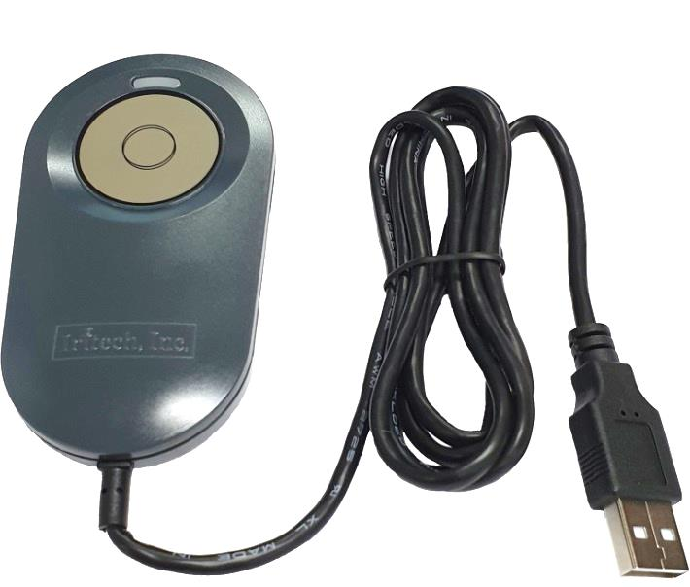

# Warnings and Precautions

IriEnvoy-MK includes sensitive electronics and optics. It is possible for IriEnvoy-MK device to get these electronics damaged if you do not follow proper precautions:

* Clean regularly to remove dust, but do not use any cleaning solutions. Only wipe the device with a smooth cloth or towel. Keep the lens free of dust and dirt, and use a special cloth for optics in order to avoid scratching the optics.
* Do not allow water to leak into the device or operate the device in humid conditions where water might condense upon the electronics.
* Do not operate device in places where temperature reach extremes beyond the stated range.
* Do not place the device next to heating equipment.
* Do not place magnets near the device.
* Do not apply voltage or current beyond the stated range.
* Do not use the device for any purposes beyond those specified.
* Do not disassemble components from the boards or alter wiring or board design.
* Do not drop the device or submit to sudden impact or mechanical stresses.
* Handle the electronics with proper anti-static protection and techniques to prevent shorting any microchips.

**Any damage to the device caused by these activities will void the warranty.**

# Product Inventory

Product type package of IriEnvoy-MK  includes the following components.

|  |  |  |
| --- | --- | --- |
| Item | | Quantity |
| Standard | **IriEnvoy-MK** | **1** |
| **Goggle** | **1** |
| **C Type OTG Gender** |  |
| **Software Package** | **1** |

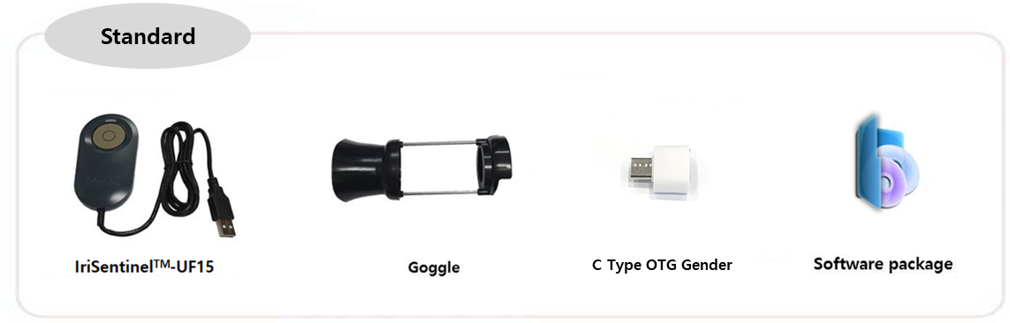

**IriEnvoy-MK**

* Software Package can be downloaded from IriTech’s Website.

# Hardware Specifications

* + **Mechanical Size**

Case Dimensions: 51.2 mm x 92.6 mm x 15.1 mm

(2 inches x 3.6 inches x 0.59 inches)

* + **Power Requirements**

Power Source: Single USB Bus Powered

Required Voltage: DC +5V ± 5% (Max = 300mA)

Power Management:

|  |  |  |
| --- | --- | --- |
| Mode | Current | Description |
|  | 30 |  |
| STANDBY | Max 120mA | Standby Mode |
| SLEEP | TBD | Sleep Mode |

* + **Environmental**

-20°C to +60°C Storage

0% to 90% humidity, non-condensing

0°C to +50°C Operating

* + **Camera Description**

Image Resolution: Output is ISO Standard of 640 x 480 pixels

(Optional: Higher Resolution output is available.)

Sensor Resolution: VGA

Pixel Density: Normally greater than 210 pixels across iris diameter

Focal Distance: 14.5cm ~ 15.5 cm (5.7 inches ~ 6.1 inches) from the camera front

(Focal Depth: 1 cm)

Optimal Distance: 15 cm (5.9 inches) from camera front

Field of View (FOV): About 3.3 cm x 2.4 cm at 15 cm (1.3 inches x 0.9 inches at 5.9 inches)

* + **Infrared LED Illumination**

Radiant Intensity: 0.2 mW/cm2 (700-900 nm)

(Less than 2% of the LED Eye Safety Standard Regulation of 10 mW/cm2.)

* + **Memory**

1024 MB NAND Flash Memory

1024 MB Mobile DDR SDRAM

* + **External Connection**

1 USB Connection (supports USB 2.0)

* + **Compliance**

Eye safety (IEC 62471:2006-07)

RoHS

FCC Class B

IP54

* + **Memory Warranty**

Iris images will be stored inside the memory of device.  This memory is warranted for storing and deleting up to 100,000 cycles.  Therefore, if the count of stored/deleted images exceed 100,000 cycles, the device will be out of warranty

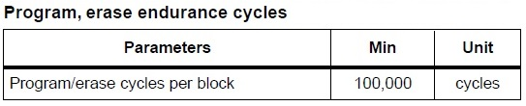

* + **Drawing**

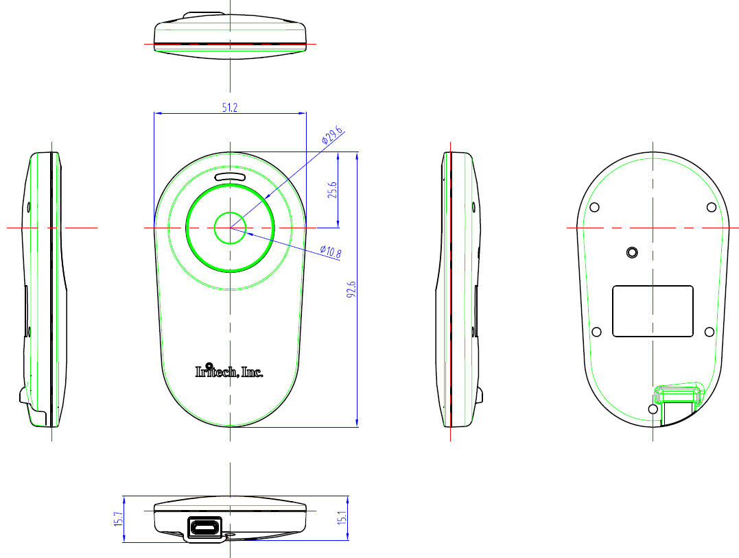

Note: All dimensions are in millimeters.

# Capture Volume

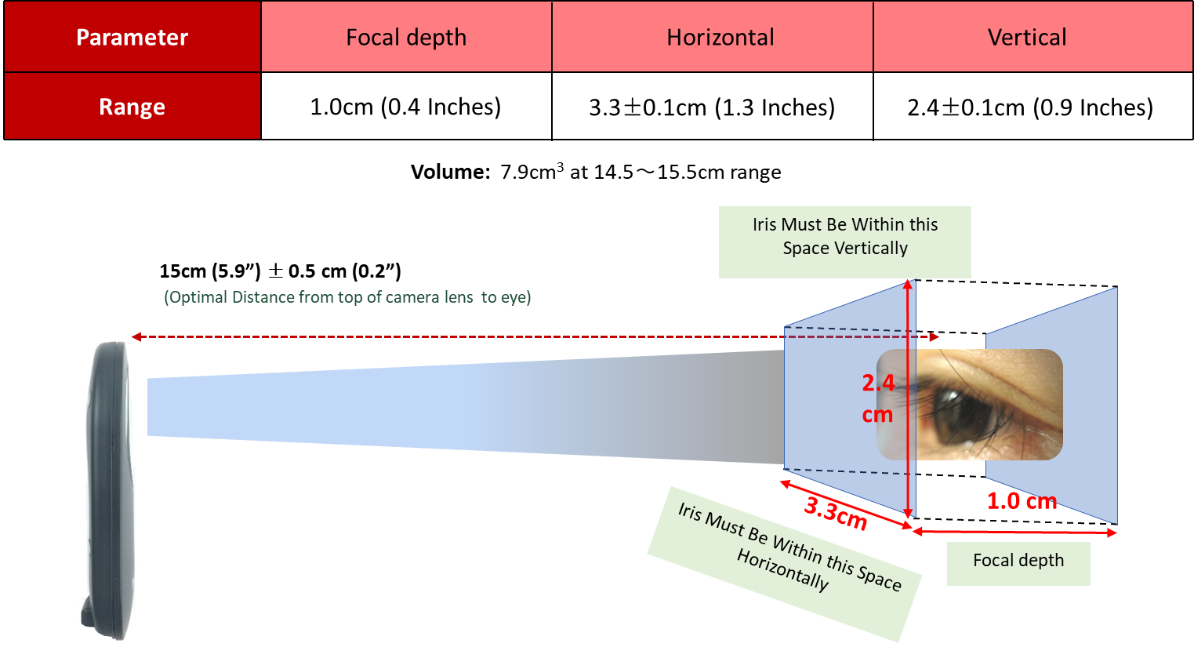

* The optimal distance for best image is 15cm (5.9 inches) from the image sensor.

# Conditions for Using USB

* The PC must be equipped with a USB 2.0 or higher Host Adapter and a USB 2.0 or higher port.
* You can verify the above conditions in the Device Manager provided by MS Windows. If there is “**Standard Extension PCI2 USB**”, “**Enhanced**”, or “**USB 2.0**”, **“USB 3.0”** listed in the Universal Serial Bus controllers, it means the PC supports USB 2.0.

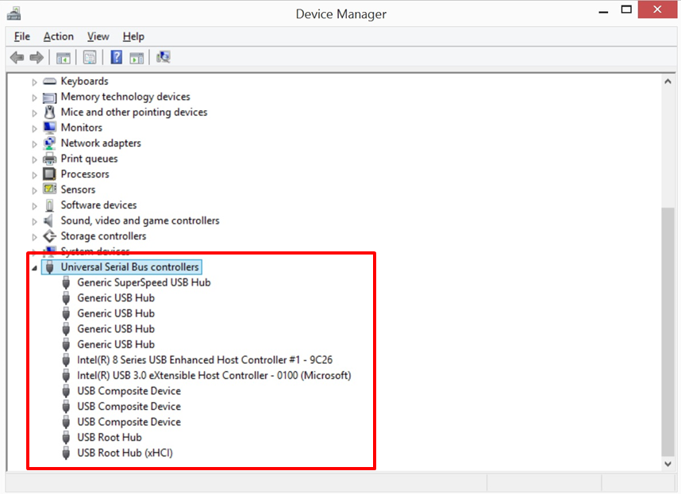

*To access the* ***Device Manager***

**(MS Windows 8 & MS Windows 10)**

1. Right-click “**Start**” button on the taskbar.
2. Click “**Device Manager**” button.

* Operating systems that support USB 2.0 include MS Windows Server 2003, and MS Windows 8.1 & MS Windows 10. You can check the system properties to make sure you are the correct version of Windows. Please contact IriTech if other operating systems need be supported.

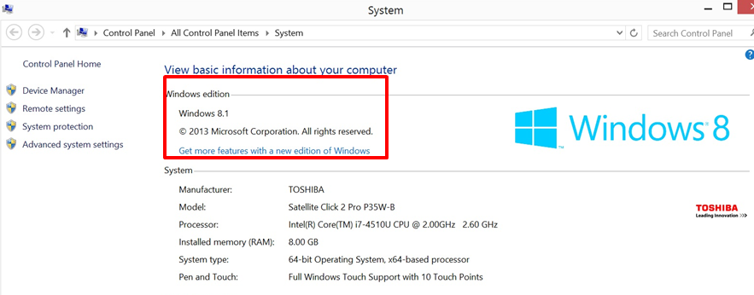

# Legal Notice

## Warranty Terms

|  |  |
| --- | --- |
| Commonly applied to entire Iris Cameras & Modules supplied by IriTech | |
| Warranty Length | 1 Year Limited: Parts & Labor, Mail in or Carry in |
| Hardware Technical Support | 1 Year |
| Software Support | 90 days |
| Website | http://www.iritech.com |
| Service Phone Number | +1 703 877 2135 (United States)  +82 2 872 3812 (Korea) |

**THIS LIMITED WARRANTY DOES NOT COVER MISUSE OR MINOR IMPERFECTIONS IN UNITS THAT MEET DESIGN SPECIFICATIONS OR IMPERFECTIONS THAT DO NOT MATERIALLY ALTER FUNCTIONALITY.**

**THIS LIMITED WARRANTY DOES NOT COVER AND IRITECH IS NOT RESPONSIBLE FOR:**

• DAMAGES CAUSED BY MISUSE, ABUSE, ACCIDENTS, FIRE, THEFT, DISAPPEARANCE, MISPLACEMENT, POWER SURGES, VIRUSES, RECKLESS, WILLFUL, OR INTENTIONAL CONDUCT.

• DAMAGES CAUSED BY SERVICING NOT AUTHORIZED BY IRITECH.

• DAMAGES CAUSED BY USAGE THAT IS NOT IN ACCORDANCE WITH PRODUCT INSTRUCTIONS.

• DAMAGES CAUSED BY FAILURE TO FOLLOW THE PRODUCT INSTRUCTIONS OR FAILURE TO PERFORM PREVENTIVE MAINTENANCE.

• DAMAGES CAUSED BY THE COMBINATION OF IRITECH PRODUCTS WITH OTHER NON-IRITECH BRANDED PRODUCTS, ACCESSORIES, PARTS OR COMPONENTS.

• SOFTWARE, INCLUDING THE OPERATING SYSTEM AND SOFTWARE ADDED TO YOUR PRODUCT THROUGH OUR FACTORY-INTEGRATION SYSTEM, THIRD-PARTY SOFTWARE, OR THE RELOADING OF SOFTWARE.

• ANY EQUIPMENT OR COMPONENTS THAT WERE NOT INCLUDED IN YOUR PRODUCT AS ORIGINALLY SOLD TO YOU.

• NORMAL WEAR AND TEAR.

• COSMETIC DAMAGE THAT DOES NOT AFFECT FUNCTIONALITY.

• PRODUCTS WHERE THE IRITECH SERIAL NUMBER IS MISSING, ALTERED OR DEFACED.

**To obtain warranty service:**

• You must assist IRITECH in diagnosing issues with your product and follow IRITECH’s warranty processes.

• You must obtain warranty service from IRITECH or an authorized service center specified by IRITECH. IRIECH will not reimburse you for service performed by others.

• You may be required to deliver and retrieve your product to and from IRITECH or an authorized service facility specified by IRITECH at your expense. When sending a product to IRITECH or the authorized service facility specified by IRITECH, you must deliver the product, freight prepaid, in either its original packaging or packaging affording an equal degree of protection. You are responsible for properly packaging your product, paying all shipping costs, loss or damage to the product during shipping, and any other taxes, fees or charges associated with transporting the product to an authorized IRITECH service facility. **YOU ARE RESPONSIBLE FOR ANY DAMAGE TO YOUR IRITECH PRODUCT DURING SHIPMENT TO US.**

• Before providing your product to IRITECH for service, remove any confidential, proprietary or personal information.

• If IRITECH asks you to return defective parts or products, you must do so within 7 days after you receive the replacement parts or products. IRITECH will charge you for replacement parts or products if you fail to do so.

IT IS YOUR RESPONSIBILITY TO BACK UP THE CONTENTS OR DATA RECORDED ON THE DEVICE BEFORE SERVICES ARE PERFORMED AND REMOVE ANY DATA FROM PARTS OR PRODUCTS RETURNED TO IRITECH. It is possible that the contents recorded will be lost or reformatted in the course of service and IRITECH will not be responsible for any damage to or loss of any programs, data, or other information stored on any media or any part of any product serviced. IF DURING THE REPAIR OF THE PRODUCT THE CONTENTS OF THE DEVICE ARE ALTERED, DELETED, OR IN ANY WAY MODIFIED, IRITECH IS NOT RESPONSIBLE FOR ANY LOSS OF YOUR DATA WHATSOEVER. YOUR PRODUCT WILL BE RETURNED TO YOU CONFIGURED AS ORIGINALLY PURCHASED (SUBJECT TO AVAILABILITY OF SOFTWARE).

1. **Implied Warranties. EXCEPT TO THE EXTENT PROHIBITED BY APPLICABLE LAW, ANY IMPLIED WARRANTY OF MERCHANTABILITY OR FITNESS FOR A PARTICULAR PURPOSE IS LIMITED IN DURATION TO THE DURATION OF THIS WARRANTY.**

Commercial Purchasers: IRITECH extends the above limited warranty to purchasers of Products for industrial, commercial and business use upon the same terms and conditions and exclusions applicable to consumer purchasers. **HOWEVER, WITH RESPECT TO COMMERCIAL PURCHASERS, ALL IMPLIED WARRANTIES, INCLUDING THE IMPLIED WARRANTIES OF MERCHANTABILITY AND FITNESS FOR A PARTICULAR PURPOSE, ARE EXCLUDED AND DISCLAIMED.**

1. **Limitation of Liability. IRITECH SHALL NOT BE LIABLE FOR ANY INCIDENTAL OR CONSEQUENTIAL DAMAGES FOR BREACH OF ANY EXPRESS OR IMPLIED WARRANTY.** IRITECH’S AND YOUR MAXIMUM LIABILITY TO THE OTHER IS LIMITED TO PURCHASE PRICE YOU PAID FOR PRODUCTS OR SERVICES PLUS INTEREST ALLOWED BY LAW. NEITHER YOU NOR IRITECH IS LIABLE TO THE OTHER IF YOU OR IT ARE UNABLE TO PERFORM DUE TO EVENTS YOU OR IT ARE NOT ABLE TO CONTROL, SUCH AS ACTS OF GOD OR FOR VIRUSES, PROPERTY DAMAGE, LOSS OF USE, INTERRUPTION OF BUSINESS, LOST PROFITS, LOST DATA OR OTHER CONSEQUENTIAL, PUNITIVE OR SPECIAL DAMAGES, HOWSOEVER CAUSED, WHETHER FOR BREACH OF WARRANTY, CONTRACT, TORT (INCLUDING NEGLIGENCE), STRICT LIABILITY OR OTHERWISE.

Some states or jurisdictions do not allow the exclusion or limitation of incidental or consequential damages, or allow limitations on how long an implied warranty lasts, so the above limitations may not apply to you. This Limited Warranty gives you specific legal rights and you may have other rights which vary from state to state or jurisdiction to jurisdiction.

**- The end of the document -**